1. Prediction of News class, sentiment (GPT Model), and tone (GPT Model).

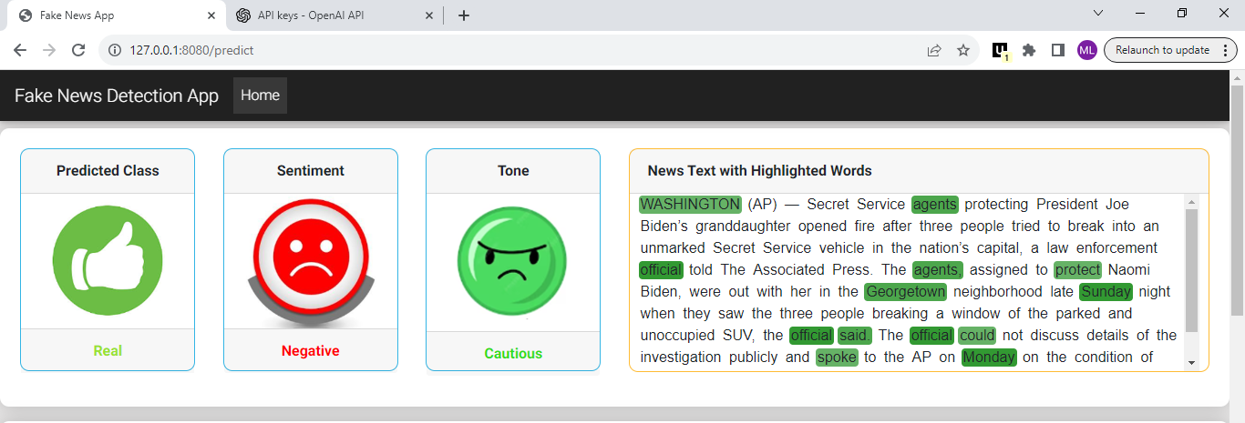

1. Model prediction interpretability – Understanding why the model categorizes news as fake or real.

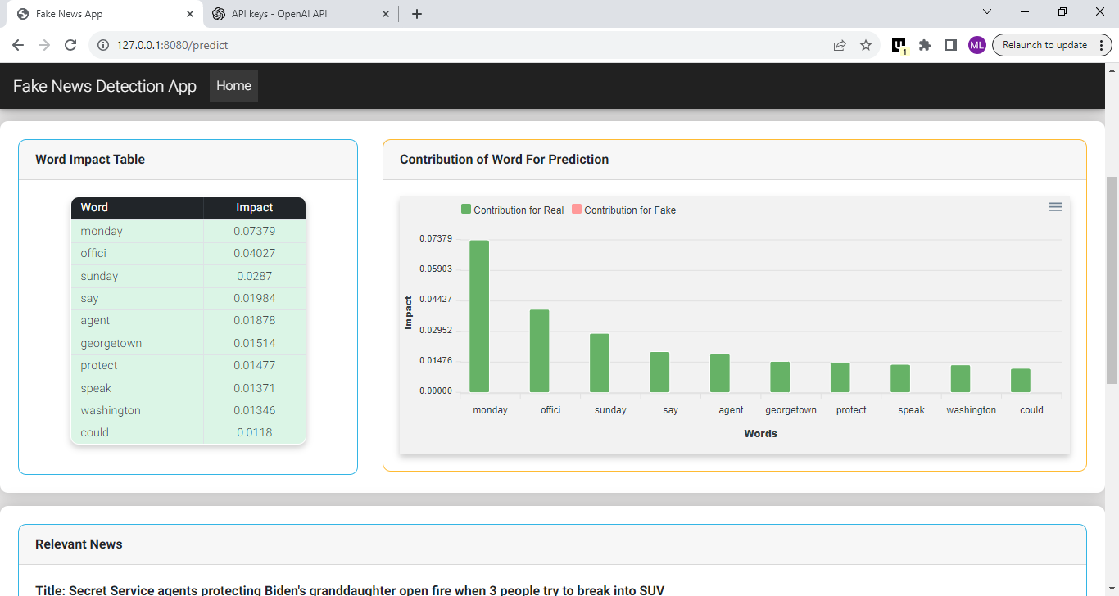

1. Obtaining relevant news related to the provided news in question.

